## 

## **Practical-6**

**Student Name:** Gauri Prabhakar **UID:** 18BCS6201

**Branch:** 18AITAIML-2 **Section/Group:** B

**Semester:** 7 **Date of Performance:** 12th October, 2021

**Subject Name:** Computer Vision Lab **Subject Code:** CSF - 432

# Aim/Overview of the practical:

To implement pose detection using mediapipe in python and OpenCV.

# Task to be done:

To implement pose detection using mediapipe in python and OpenCV.

# Steps to be followed:

1. Importing necessary modules.
2. We will use 'drawing_utils' to draw the key points.
3. Importing 'mp.solutions.pose' to a variable 'mp_pose'.
4. Creating a variable to store the video using the '.VideoCapture()' function.
5. Specifying the detection and tracking confidence uisng 'mp_pose.pose()'.
6. While the video is running.
7. Capturing the video frame by frame using the '.read()' method.
8. To improve performance, marking the image as not writable and passing by reference.
9. Reading the frames and converting them to RGB.
10. Detecting poses in the frame using the function 'pose.process()'.
11. Drawing the pose annotations on the image.
12. Reading the frames and converting them to RGB.
13. Connecting the key points using the function 'mp_drawing.draw_landmarks()'.
14. Rendering the video with effective Posetracking to the console by using the function '.imshow()'.
15. Setting up '.waitkey()' to wait for a specific time until any key is pressed and break the loop.
16. '.waitkey(1)' displays a frame for 1ms after which it moves to the next frame in the video.
17. Setting 'x' as the quitting button.
18. Releasing the variable/object 'cap'.
19. **Result/Output/Writing Summary:**

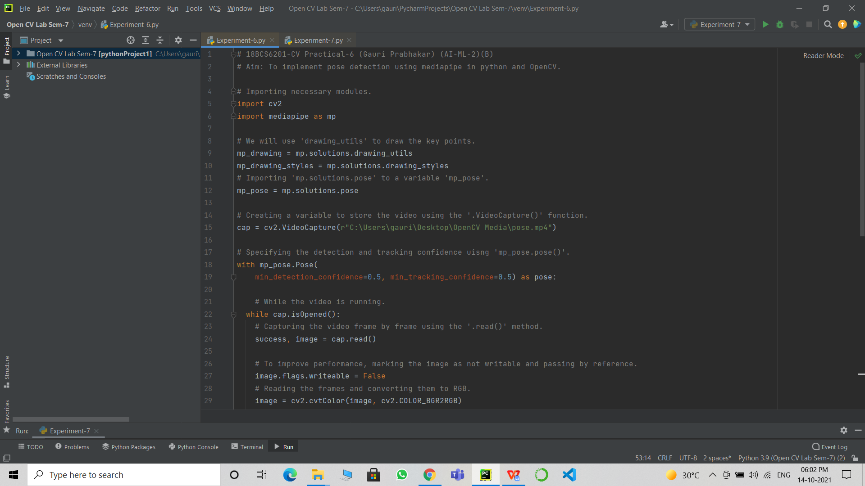

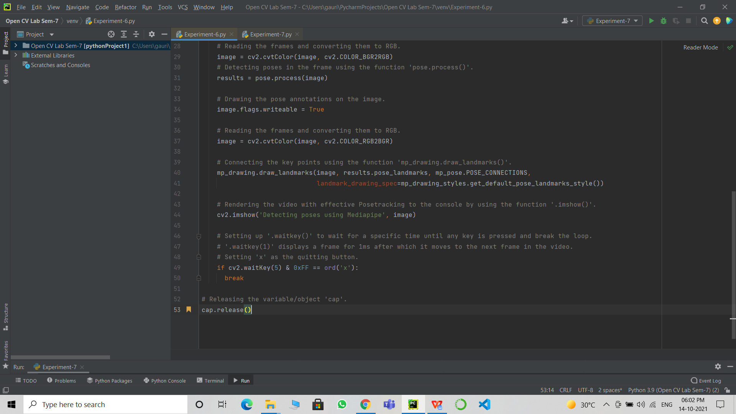

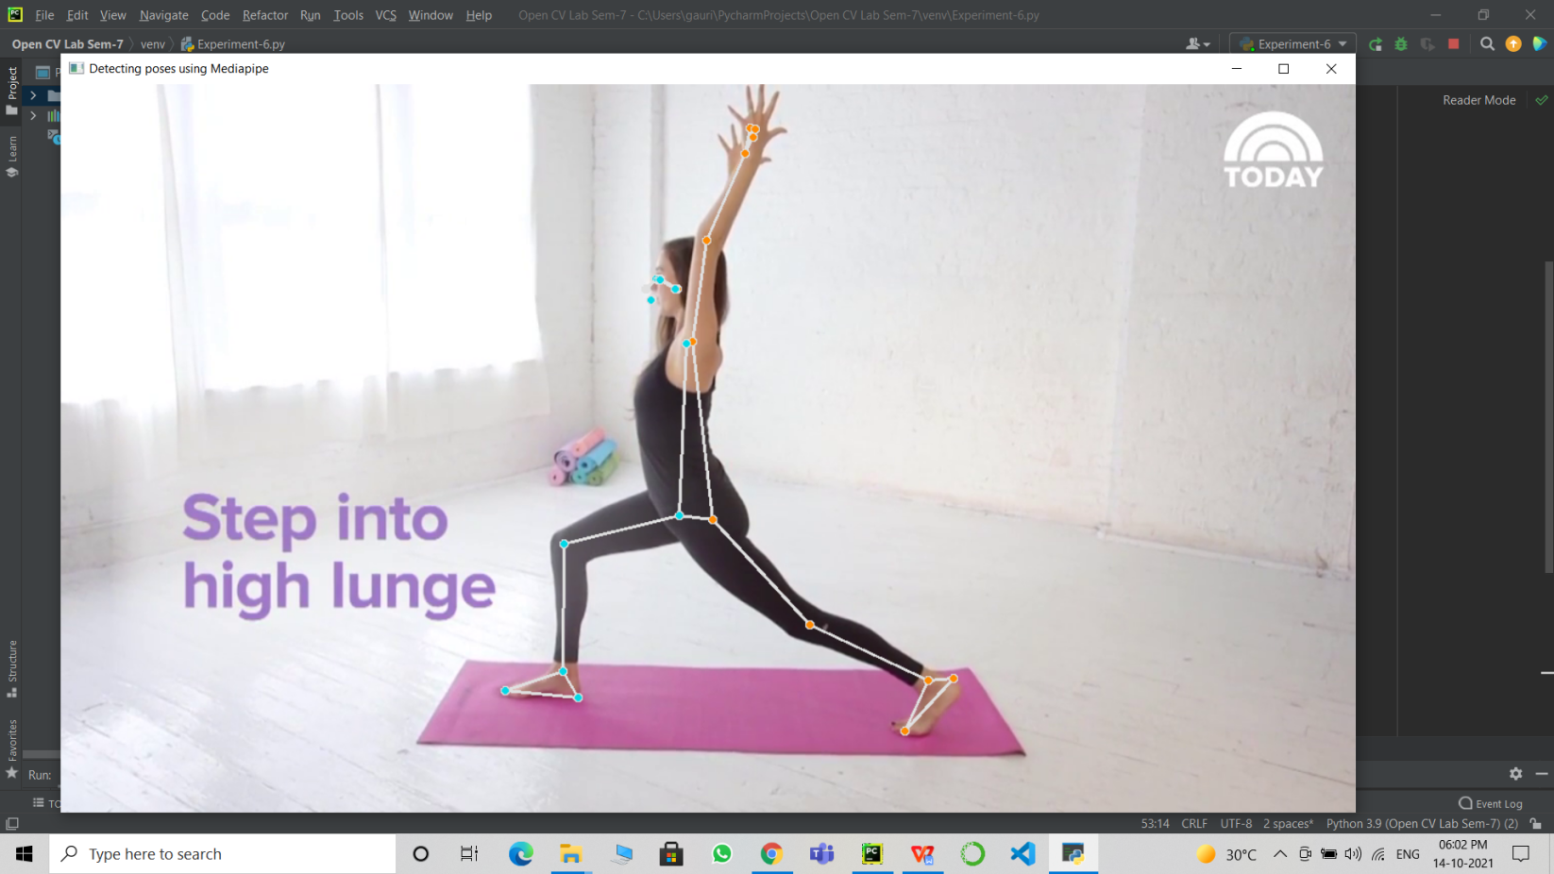

# Learning outcomes (What I have learnt):

* Open CV modules.
* The mediapipe library.
* Detect poses using the mediapipe library.
* Pose tracking a saved video.
* Highlighting key points.

**Evaluation Grid (To be created as per the SOP and Assessment guidelines by the faculty):**

|  |  |  |  |
| --- | --- | --- | --- |
| Sr. No. | Parameters | Marks Obtained | Maximum Marks |
| 1. |  |  |  |
| 2. |  |  |  |
| 3. |  |  |  |